ECON 136: Week 4, Monday
Class Tasks

Sit with someone using the same spreadsheet/word processor on the same device.

My goals for today are

1) Understand that price or cost in economics is fundamentally opportunity cost.

2) Start to get a feel for how economists use Y-X diagrams to illustrate relationships

3) Why are budget lines straight and production possibility frontiers usually bowed out?

4) Draw a budget line in a spreadsheet

5) Draw a budget line using drawing tools

6) Insert your diagram in a document

7) (If time) Draw a production possibility frontier

A) Opportunity Cost

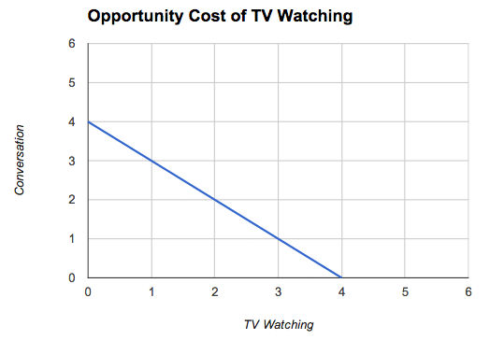
The opportunity cost of a good, service or activity is what must be given up to obtain it – the next best use of your available resources.

1) The most basic of all resources is time

Example A1: Mary has 4 hours available and can either spend it watching TV or in conversation (C) with friends. The cost of devoting an additional hour to watching TV is the hour taken away from (not available for) conversation.

The 4 hours is Mary’s endowment or time (her wealth) or time income.

4 = C + TV or C = 4 – TV

A2: Time on task is not uniformly productive. Suppose I could spend the day splitting wood or making Scottish shortbread. And assume I have all the ingredients at hand.

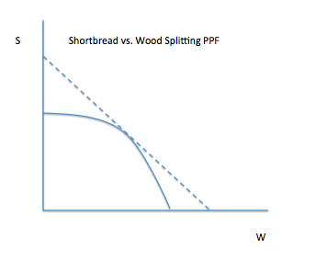
Now, If I spent half my time on splitting wood and half my time on baking I could split 2 cords of wood or 2 dozen shortbread cakes. But, that doesn’t mean I could split 4 cords of wood by devoting all my time to doing so.

My production possibility frontier is bowed out. The opportunity cost of my splitting wood, rises as I (devote more time) to split wood.

B) Opportunity Cost in terms of Money Income

Example: Here’s the first Sapling Learning problem from last night:
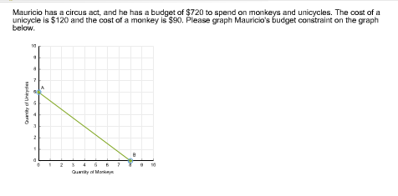

The cost or price of unicycles (monkeys) tells Mauricio the rate at which he can turn his budgeted amount into number of unicycles (monkeys).

Maximum unicycles = I/P_{U} = 720/120 = 6

I = P_{U}U+ P_{M}M or 720 = 120U + 90M

U = 720/120 - (90/120)M = 6 – 0.75M

It’s not the $ that matter, it’s the number of unicycles that Mauricio must give up to have more monkeys – the opportunity cost of monkeys.

C) Creating Diagrams

Task C1) Create the opportunity cost of TV watching diagram using a spreadsheet program – going back to the first page.

Task C2) Do on your own after class: Create Mauricio’s budget constraint using a spreadsheet program.

Task C3) Create the opportunity cost of TV watching diagram using drawing tools

Task C4) Create the PPF diagram using drawing tools

Before we can leave (I’ll try to stop us at 10:55), we need to get the tables and chairs back into the open donut shape configuration other classes will expect.

